

IKT203 Algorithms and Data Structures
Project 6: Expression Parsing and Evaluation

Date handed out:
Date submission due:

Description

In computer science and linguistics, parsing, or, more formally, syntactic analysis, is the process of analyzing a sequence of tokens (for example, words) to determine their grammatical structure with respect to a given (more or less) formal grammar. In computing, a parser is one of the components in an interpreter or compiler, which checks for correct syntax and builds a data structure (often some kind of parse tree, abstract syntax tree or other hierarchical structure) implicit in the input tokens. The parser often uses a separate lexical analyser to create tokens from the sequence of input characters. Parsers may be programmed by hand or may be semi-automatically generated (in some programming languages) by a tool (such as Yacc) from a grammar written in Backus-Naur form. This is what most compilers do as an intermediate step towards compiling a program.

Arithmetic expressions can be represented by the following formal grammar:

<expression> ::= <term> |<expression> + <term> | <expression> – <term>
<term> ::= <factor> | <term> * <factor> | <term> / <factor>
<factor> ::= <value> | ( <expression> )
<value> ::= <variable> | <integer>

Example

Consider the following arithmetic expression:

100*(3+4) 10*(8/2)

Its equivalent parse tree is shown below:

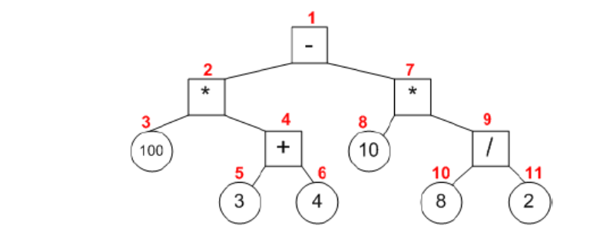

Deliverables

Your program will have the following functionality:

- Read the expression from left to right and check whether it is syntactically correct arithmetic expression. You will use a recursive descent approach (more on this during the tutorials).
- Build a parse tree for the expression. This parse tree will be a binary tree where nodes either hold values or operators.
- Prompt the user for providing values for variables.
- Evaluate the expression by traversing the tree (in which order do you have to traverse this tree?)
- Print the parse tree.
- Print the structure of the parse tree.

Programming Directives

In this project, you will write an interpreter for arithmetic expressions. Arithmetic expressions can be represented by the following formal grammar:

<expression> ::= <term> |<expression> + <term> | <expression> – <term>.
<term> ::= <factor> | <term> * <factor> | <term> / <factor>.
<factor> ::= <variable> | <value> | ( <expression> ).
<value> ::= <variable> | <integer>.

Evaluation of an arithmetic expression has three components: lexical analysis, parsing and evaluation.

We have given you a skeleton of the program to be written which includes the definition of the data structures as well unfinished codes for the processing of expressions, terms and factors as well as a code fragment for the evaluation of an expression. You are to use these skeletons for the completion of this project.

Lexical Analysis of Arithmetic Expressions

Here, we only concern ourselves with the lexical analysis of arithmetic expressions. We will need a few auxiliary functions for the lexical analysis of expressions as follows:

int NotEmpty(char *expression);
/* returns true if expression is not empty string*/

char NextChar(char *expression);
/* returns next character in expression, but nothing is consumed */

char GetNextChar(char *expression);
/* returns next character in expression, but a character is consumed */

int IsNum(char *ch);
/* checks whether ch is a character between ‘0’ and ‘9’ */

int GetNum(char *expression);
/* returns value of next integer in expression, and integer is consumed */

To evaluate an expression E, we will do the following:

- Evaluate the next term in E, and call the result X.
- While the next character in E is an operator (“+” or “–”)
  - Read past the operator.
  - Evaluate the next term in E, calling the result Y.
  - Let X be X + Y or X – Y, depending on the operator.
- The value of E is the final value of X.

Here is the code for the lexical analysis of expressions:

void EvalExpression(char *expression, int *result)
{
int temp;
char op;

EvalTerm(expression), result);
while ((NotEmpty(expression)) && (NextChar(expression) == ‘+’)
|| (NextChar(expression) == ‘-‘))
{
op = GetNexChar(expression);
EvalTerm(expression, temp);
if (op == ‘+’)
result = result + temp;
else
result = result – temp;

}
}

Similar functions can be written for the lexical analysis of terms and factors as per the formal definition. Please note that these three functions EvalExpression(), EvalTerm() and EvalFactor() will mutually call it each other recursively.

We recommend that you first fully implement the lexical analysis of arithmetic expressions before you proceed to the implementation of parse trees.

Building Parse Trees for Arithmetic Expressions

A parse tree is a tree structure representing sentences or expressions of a formal language that mirrors the grammar of that language, as defined by its grammar. It can be used for evaluation and optimization of an expression.

First, we define the data structure for a node in the parse tree:

struct TreeNode
{
int isLeaf;
int number;
TreeNode* leftTree;
TreeNode* rightTree;
char op;
};

typedef TreeNode* TreePtr;

We will need a few auxiliary functions for accessing a parse as follows:

int IsLeafNode(TreePtr tree);
/* returns true if tree points to a leaf node */

int LeafValue(TreePtr tree);
/* returns number at leaf node */

int NodeOperator(TreePtr tree);
/* returns operator at internal tree node */

TreePtr LeftTree(TreePtr tree);
/* returns left subtree of a node */

TreePtr RightTree(TreePtr tree);
/* returns right subtree of a node */

In addition, we need the following two functions for building the parse tree:

TreePtr BuildLeaf(int val);
/* build a leaf node in the parse tree and return */
/* the pointer to the node */

TreePtr BuildNode(int val);
/* build an internal node in the parse tree and */
/* return the pointer to the node */

The functions that turn expressions into parse tree are similar to the functions for the lexical analysis of expressions but with added functionality. Here is the code for the lexical analysis and parsing of arithmetic expressions:

void ParseExpression(char *expression, TreePtr exprTree)
{
TreePtr tempTree;
char op;

ParseTerm(expression), exprTree);
while ((NotEmpty(expression)) && (NextChar(expression) == ‘+’)
|| (NextChar(expression) == ‘-‘))
{
op = GetNexChar(expression);
ParseTerm(expression, tempTree);
exprTree = BuildNode(exprTree, tempTree, op);

}
}

Similar functions can be written for parsing terms and factors as per the formal definition.

Evaluation of Arithmetic Expressions

The routine for evaluating an arithmetic expression from its parse tree simply traverses the tree and apply the operators in the nodes. Here, we show the implementation for evaluating additions:

int EvalExpressionTree(TreePtr exprTree)
{
int result;

if isLeafNode(exprTree)
result = LeafValue(exprTree);
else
{
switch(NodeOperator(exprTree))
{
case ‘+’:
result = EvalExpressionTree(LeftTree(exprTree)) +
EvalExpressionTree(RightTree(exprTree));
break;
default:
result = 0;
fprintf(stderr, “Error in evaluating expression
tree\n”);
}
}
return result;
}

It is easy to extend this routine to also deal with the other arithmetic operators.

Extra Credit Problem

The implementation of the tree traversal uses recursion as a method for returning to the parent of a child node eventually returning to the root of the expression tree. It is possible to implement an iterative tree traversal algorithm without the use of either recursion or a stack if one uses a threaded binary tree: A binary tree is threaded by making all right child pointers that would normally be null point to the inorder successor of the node, and all left child pointers that would normally be null point to the inorder predecessor of the node.

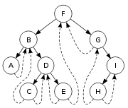
A threaded binary tree makes it possible to traverse the values in the binary tree via a linear traversal that is more rapid than a recursive traversal.
It is also possible to discover the parent of a node from a threaded binary tree, without explicit use of parent pointers or a stack, albeit slowly. This can be useful where stack space is limited, or where a stack of parent pointers is unavailable.
This is possible, because if a node (k) has a right child (m) then m's left pointer must be either a child, or a thread back to k. In the case of a left child, that left child must also have a left child or a thread back to k, and so we can follow m's left children until we find a thread, pointing back to k. The situation is similar for when m is the left child of k.
Check Google for code on how to build and traverse a binary threaded binary tree.

Grading

The breakdown of the grading will be as follows:

Aspect | Marks (Total 100)
Getting the next symbol | 10
Parsing expressions | 10
Parsiing terms | 10
Parsing factors | 10
Implementation of access routines for parse tree | 20
Evaluation of the expression tree | 20
Displaying the parse tree as a tree | 20
Extra Marks
Implementation of a threaded binary expression tree | 20

